**Text Data - Sentiment Analysis**

**Dataset Link -** [**txt_reviews.zip**](https://drive.google.com/file/d/1Y0QGzCYvQxlgv83Ojmr9kmLGrlg98o6P/view?usp=sharing)

**Data Description**

This dataset consists of reviews of fine foods from amazon. The data span a period of more than 10 years, including all ~500,000 reviews up to October 2012. Reviews include product and user information, ratings, and a plain text review. It also includes reviews from all other Amazon categories.

**Data includes:**

* Reviews from Oct 1999 - Oct 2012 - 568,454 reviews
* 256,059 Users and 74,258 products
* 260 users with > 50 reviews

**Below attached is the screenshot of product review from Amazon Website.**

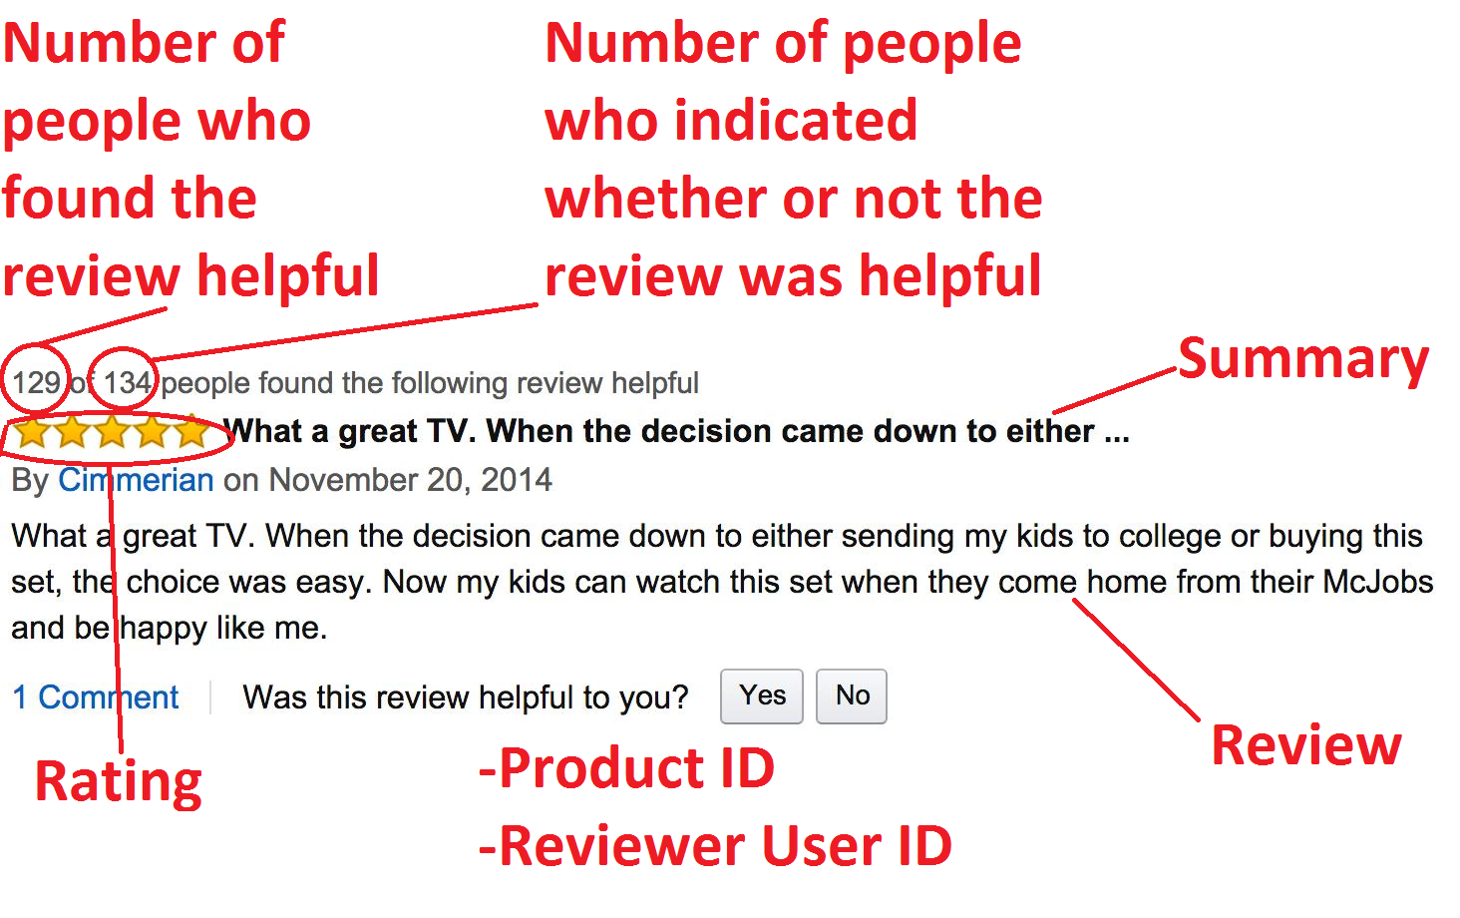

**SPRINT 1 - Create DataFrame from raw text files**

Given data consists of 568,454 text files. Each text file looks like the below attached image:

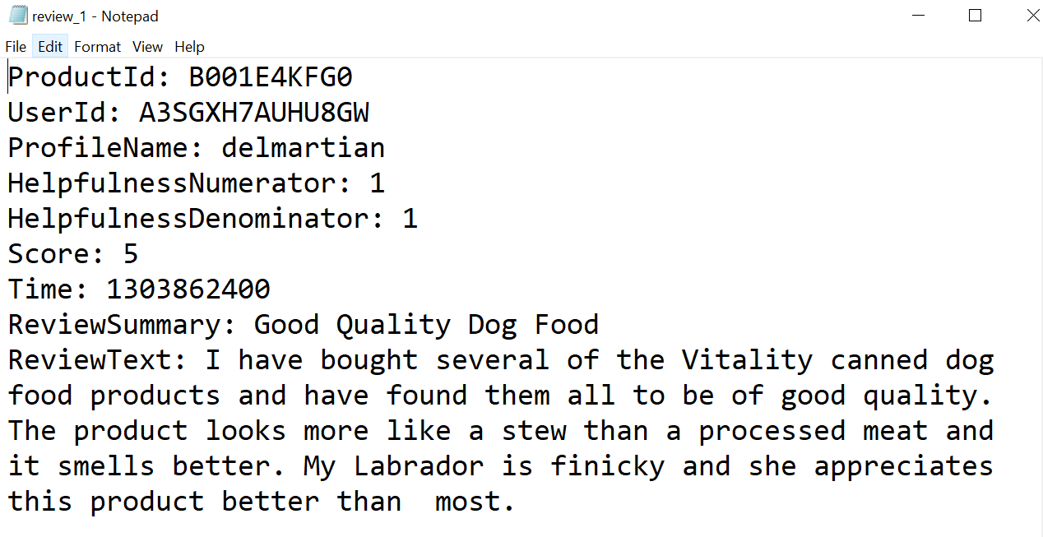

**Task -** Your task here is to use your Data Engineering skills to transform the given data(i.e. Text files) to tabular format(i.e. csv file). The columns in this .csv file should be:

* Id - Unique row number
* ProductId - Unique identifier for the product
* UserId - Unique identifier for the user
* ProfileName
* HelpfulnessNumerator - Number of users who found the review helpful
* HelpfulnessDenominator - Number of users who indicated whether they found the review helpful
* Score - Rating between 1 and 5
* Time - Timestamp for the review
* ReviewSummary - Brief summary of the review
* ReviewText - Text of the review

NOTE - Helpfulness (fraction of users who found the review helpful) = HelpfulnessNumerator / HelpfulnessDenominator

**SPRINT 2 - Build a model**

**Task A -** Perform data preprocessing on the given text data and convert it into numerical vectors.

**Task B -** Build models to predict the Score of a given text review.